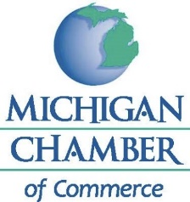

FOR IMMEDIATE RELEASE CONTACT: Wendy Block
September 10, 2021 517/371-7678

Leah Robinson Joins the Michigan Chamber as Director of Tax Policy & Legislative Affairs
LANSING, Mich. (September 10, 2021) — The Michigan Chamber announces the appointment of Leah Robinson as Director of Tax Policy & Legislative Affairs. She is also responsible for staffing, organizing and directing the Chamber’s Tax Policy Advisory Committee.
“We are excited to welcome Leah to our team,” said Wendy Block, Vice President of Business Advocacy and Member Engagement for the Michigan Chamber. “Leah has the policy background and relationships necessary to hit the ground running and be an effective advocate for Chamber members.”
“I am honored to have the opportunity to work with the Chamber to help ensure free enterprise and promote job competitiveness in Michigan,” said Leah Robinson, Director of Tax Policy & Legislative Affairs for the Michigan Chamber. “After seeing the impact of COVID-19, it is critical to protect the businesses who make up our unique state and emphasize their crucial role to Michigan’s economy.
“I am thrilled to help champion these efforts with the Chamber,” continued Robinson.
Robinson comes to the Michigan Chamber with expertise on wide-ranging policy initiatives after working in Washington DC and serving in the Michigan House of Representatives as a legislative director and policy advisor. Robinson, who received a Bachelor and Master of Arts degree in Political Science from Virginia Tech, handled multiple policy portfolios while in the Michigan Legislature, including guidance and analysis for businesses during the COVID-19 pandemic and the subsequent Executive Orders.
If you would like to reach out to Leah, she can be reached at lrobinson@michamber.com.

