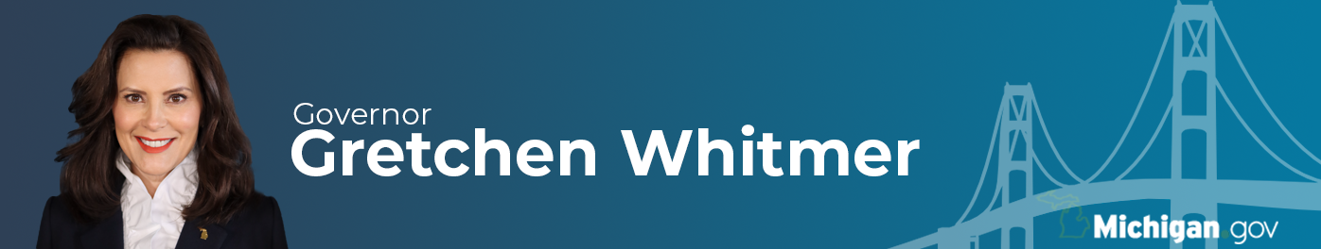
FOR IMMEDIATE RELEASE
May 20, 2021
Contact: Press@Michigan.gov

Gov. Whitmer Announces Bipartisan Agreement to Advance Fully Negotiated Budget, Invest American Rescue Plan Dollars to Support Michigan Jobs
State Budget Director to Meet With Appropriations Chairs to Negotiate State Budget

LANSING, Mich. — Governor Gretchen Whitmer today announced a bipartisan agreement with Senate Majority Leader Mike Shirkey (R-Clarklake) and Speaker of the House Jason Wentworth (R-Farwell). Republicans have agreed to fully negotiate the state budget and federal funding from the CARES Act and the American Rescue Act with the State Budget Director. Governor Whitmer has agreed to withdraw the Michigan Occupational Safety and Health Administration’s (MIOSHA) proposed permanent rules, and to have a conversation about formalizing legislative input on epidemic orders.

“As we emerge from the pandemic together, our number one goal is to get Michigan back to work and jumpstart our economic recovery,” said Governor Gretchen Whitmer. “Today’s bipartisan framework shows how we can unite around investing in our schools, small businesses, and communities to help them thrive. I look forward to working with the legislature to invest the billions in federal resources sent to us by both the Trump and Biden administrations and pass a budget that makes lasting investments in our shared priorities. Throughout the pandemic, we saw Michiganders all over the state step up and come together to slow the spread of COVID-19 and save lives. Now, Michigan’s task is to unleash the potential of our people, to drive innovation and investment, and create tens of thousands of jobs and economic prosperity for all. Together, we can stay laser-focused on growing the economy and getting Michiganders back to work. Let’s hit the gas.”

As the focus now shifts to working on the state budget, and with the large boost in state revenues to be announced tomorrow at the Consensus Revenue Estimating Conference, Michigan is in a very strong position to make large investments that can transform the state and help our residents and businesses recover from the pandemic. With more than $2 billion remaining in CARES act funding, nearly $20 billion in funding from the American Rescue Plan, and now a large influx of additional state revenue, this is a moment in Michigan’s history that can deliver real and lasting positive outcomes for the state.

“I am excited to get to work and partner with my colleagues in the Legislature. I am confident we can work together to make sure we make the right investments and put a budget plan together that will enable Michigan to thrive in the future,” said Director Massaron, State Budget Office. “Thanks to the governor’s leadership, we have emerged from the pandemic in a very strong financial position and now we have the resources at our fingertips to solve problems. This is a unique opportunity to make a lasting and positive impact on our state and I look forward to the budget work ahead.”

Under the agreed framework, the administration would rescind MIOSHA’s draft permanent rules, and the public hearing scheduled for May 26 will be canceled. Based on the science at the time the process of creating permanent rules began, the agency used the process provided by law to ensure it could continue to keep employees safe if needed when the emergency rules expired. With rising vaccination rates and falling case numbers, along with the recent updates from the CDC, MIOSHA is confident that completing the normal rulemaking will not be necessary.

In addition, now that the state has reached the 55% vaccination threshold and in accordance with the governor’s MI Vacc to Normal plan, MIOSHA will remove the requirement that employers create a “policy prohibiting in-person work for employees to the extent that their work activities can feasibly be completed remotely.” MIOSHA will also be updating other aspects of the emergency rules to reflect recent guidance from the CDC and MDHHS, which will take effect May 24.

“MIOSHA has a duty to protect Michigan workers and the agency’s emergency rules have provided employers and employees with the guidance and certainty they needed to stay safe,” said Michigan COVID-19 Workplace Safety Director Sean Egan. “The agency has the flexibility it needs to ensure consistency with public health guidelines to protect working people.”

QUOTES FROM BUSINESS AND LABOR LEADERS
“This is a huge day for small business owners everywhere. We now have a date certain when capacity restrictions will be lifted, the prospect of permanent workplace rules is being pulled off the table, and all parties are committed to working together on potential future epidemic emergency orders. This will give entrepreneurs a much more clear and certain pathway to recovery. We applaud the Governor and the Legislature for working hard to come together and putting aside their differences in this comprehensive agreement.”
- Brian Calley, president of the Small Business Association of Michigan.

“The Chamber applauds Governor Whitmer, Majority Leader Shirkey, and Speaker Wentworth for their leadership and a renewed spirit of bipartisan cooperation to put forward solutions that will help end the pandemic through increased vaccinations and let businesses operate with certainty. Businesses and business organizations have highlighted our concerns regarding MIOSHA making COVID-19 Emergency Rules permanent. Today’s announcement of MIOSHA’s withdrawal of the proposed permanent rules, coupled with a clearer path forward for substantive budget negotiations, is the welcome news that many of us have sought and helps accelerate our state’s economic recovery.”
- Sandy K. Baruah, president and chief executive officer of the Detroit Regional Chamber.

“The Governor’s gradual lift of the state’s mask wearing mandate is a direct measure of needed recovery. However we must collectively proceed with both caution and common sense. The safety and health of UFCW 876 members working in our grocery stores, food processing plants, emergency services and pharmacies are dependent upon the timely decisions and actions of their employers. Ultimately, it will be these decisions that keep our state healthy.”
- Dan Pedersen, president of the United Food and Commercial Workers Union Local 876.

###

