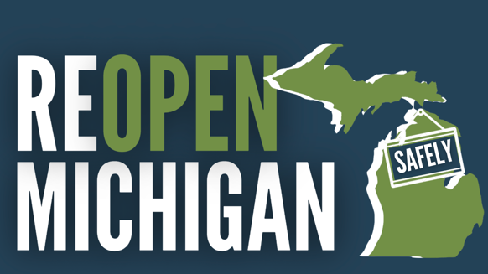

Whitmer’s Office Ban Extension Ignores Job Creators and Damages Michigan’s Economy
April 13, 2021 – LANSING – The Reopen Michigan Safely coalition of thousands of businesses today said it opposes Gov. Gretchen Whitmer’s predetermined extension of Michigan Occupational Safety and Administration (MIOSHA) COVID emergency rules that essentially ban the safe reopening of office spaces for up to another six months, despite little evidence that carefully managed offices are sources of spread.
Whitmer’s restrictions are making it extremely difficult for businesses to remain competitive versus other states where employees can safely work together to innovate in response to myriad challenges created by the pandemic. It is also well-documented that workers are suffering from negative mental health impacts caused by isolation related, in part, to the office ban. Additionally, Michigan’s downtowns and municipal governments are taking a beating as Whitmer’s rules virtually eliminate millions in economic activity that would otherwise take place if office workers were present.
Leaders from the Reopen Michigan Safely coalition agree that the extension of the blanket office ban is bad news for our economy at a time when government should be working with and trusting state job creators:
RICH STUDLEY, MICHIGAN CHAMBER PRESIDENT & CEO
“Extending these rules for another six months is a body blow many businesses may never recover from. Despite the rapid distribution of COVID-19 vaccines and the ability to safely manage office spaces, the Governor used workgroups as cover for her predetermined decision to close businesses for up to a year. Gov. Whitmer’s inability to find ways to work with job creators to restart our economy is a complete leadership failure that will cause economic pain for Michigan workers for years to come.”
RICK BAKER, GRAND RAPIDS CHAMBER PRESIDENT & CEO
“We need action, not more delay on allowing employees to safely return to the office. Michigan businesses have demonstrated for more than a year that they can follow the proper health requirements to create safe working environments. A half year more of empty office buildings will have a damaging impact not only on productivity, innovation, collaboration and mental health, but on communities across the state.”
VERONICA HORN, SAGINAW CHAMBER PRESIDENT & CEO
“We are truly disappointed in this decision. The private sector, business owners and their staff are the best judge of how to safely bring their employees back to the workplace using approved safety protocols. Government can only use a “one size fits all” solution, which is no solution at all.”
RONALD HINRICHS, SOUTHERN WAYNE COUNTY CHAMBER PRESIDENT & CEO
“It is critical that we as a state continue to move forward to safely and responsibly reopen Michigan’s workplaces in a timely manner. As businesses and organizations across our State contemplate operational decisions that will have a lasting impact on the health of our small businesses, Downtowns, and overall communities, it is urgent that all voices from all industries and sectors of our economy be involved in the discussion and decision-making process. We must ensure that our workforce and job providers have the opportunity and resources necessary to safely reopen workplaces now, and effectively drive economic activity which is the lifeline of our communities. By working together, Michigan’s employers and employees can safely, responsibly, timely, and reasonably reopen the workplaces that mean so much to the livelihood and health of our citizens.”
KARA BEER, BATTLE CREEK CHAMBER PRESIDENT & CEO
“Michigan businesses have been dealt another defeating blow with the extension of the MIOSHA ruling. Another mandate for an additional six months of working from home and prohibiting employees to safely return to the office may cause businesses to never recover, closing more brick-and-mortar businesses in our communities. This ruling shows the inability of finding ways to work with job creators to restart our economy and causing further economic loss for Michigan workers, loss of innovation, collaboration, and the mental health of our communities. We need to do better for our small and large businesses and their employees.”

BACKGROUND
Whitmer originally put the temporary emergency rules in place in October 2020. They were due to expire on April 14th.
In advance of that deadline, the Reopen Michigan Safely coalition last month called on Whitmer to loosen the office ban and allow job creators to develop individual plans to reopen offices safely. Originally starting with eight business groups, the Reopen Michigan Safely coalition rapidly grew to more than 50 groups made up of thousands of individual business members.
Whitmer’s MIOSHA emergency rules provide extensive protocols for operating safely but prohibit most in-person work. This means businesses and employers are barred from finding ways to safely reopen offices in ways that will keep our jobs and economy alive. The rules state: “The employer shall create a policy prohibiting in-person work for employees to the extent that their work activities can feasibly be completed remotely.”
LEARN MORE
The Reopen Michigan Safely coalition can be found online at www.ReopenMichiganSafely.com, on Facebook at facebook.com/reopenmichigansafely and Twitter at @ReopenMISafely.

